**Step 1:** Login to [GST Portal](https://services.gst.gov.in/services/login)

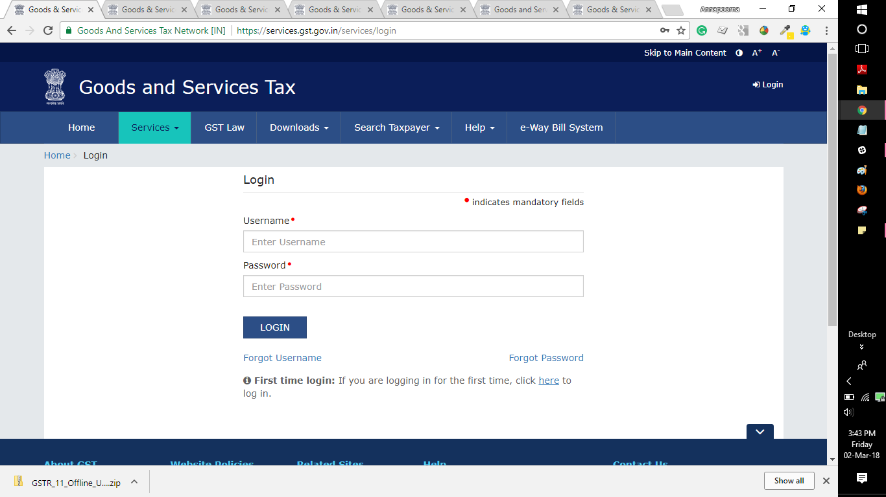  
**Step 2:** Go to  ‘SERVICES’ Tab > ‘User Services’ > Select ‘Furnish Letter of Undertaking(LUT)’  
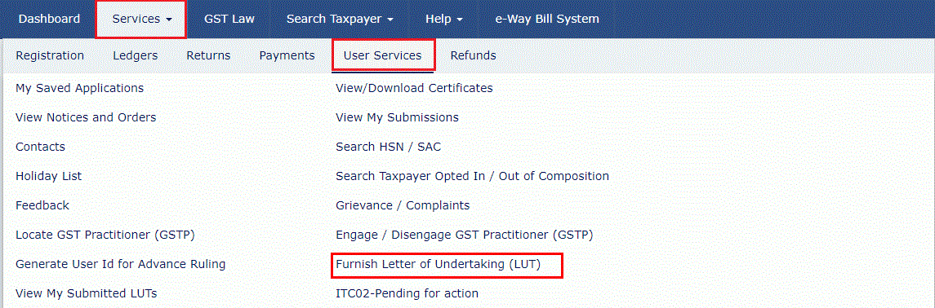

**Step 3:** Select the financial year for which Letter of Undertaking is applied for from the ‘LUT Applied for Financial Year’ drop-down list. Eg: 2020-21

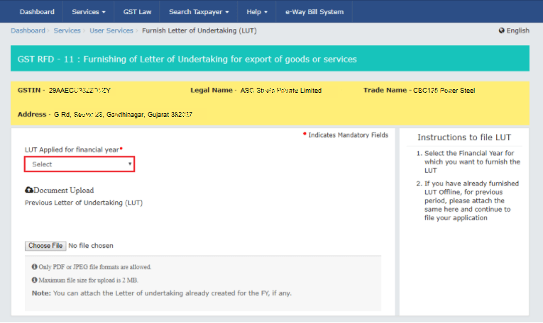

Note: **If Letter of undertaking has been already furnished manually for any of the previous periods**, then please upload the same by Clicking on ‘Choose File’ option on the same window.

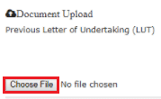

Ensure:

1. Only PDF or JPEG file formats are allowed.
2. Maximum file size for upload is 2 MB

Step 4: Fill up the necessary details on the Letter of Undertaking Form/ GST RFD-11 that appears on the screen

The following needs to be done on the form:

1. **Self-Declaration**: Tick mark by clicking against each of the three boxes

By doing this, Exporter undertakes the following :

a) Export of goods/services will be completed within a period of three months from the date of issue of Export invoice or further period allowed by the Commissioner if any.

b) To abide by GST law in respect of exports

c) To pay IGST along with Interest* if failed to Export

**\*** Interest must be paid at the rate of 18% per annum for the period From date of issue of export invoice upto date of Payment of IGST

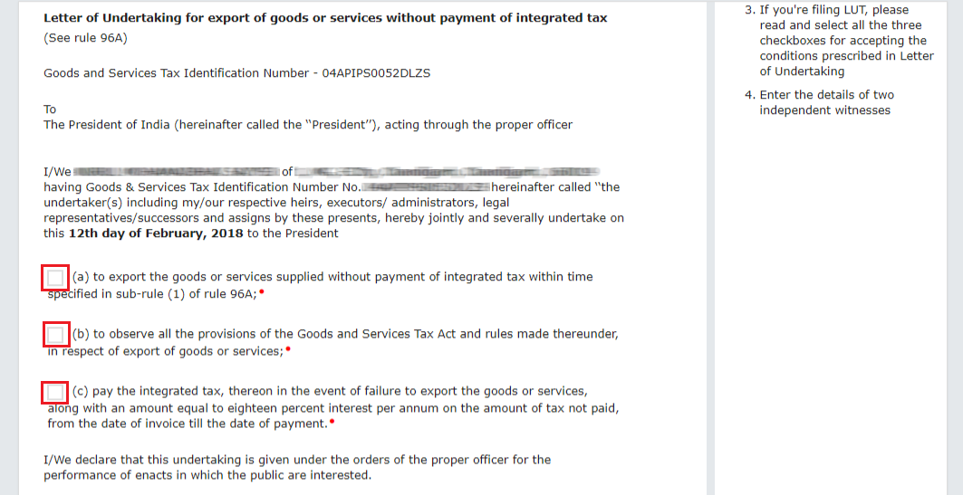

1. **Give Independent Witnesses Information**: Mention the Name, Occupation and Address of two independent witnesses in the boxes highlighted in red color mandatorily.

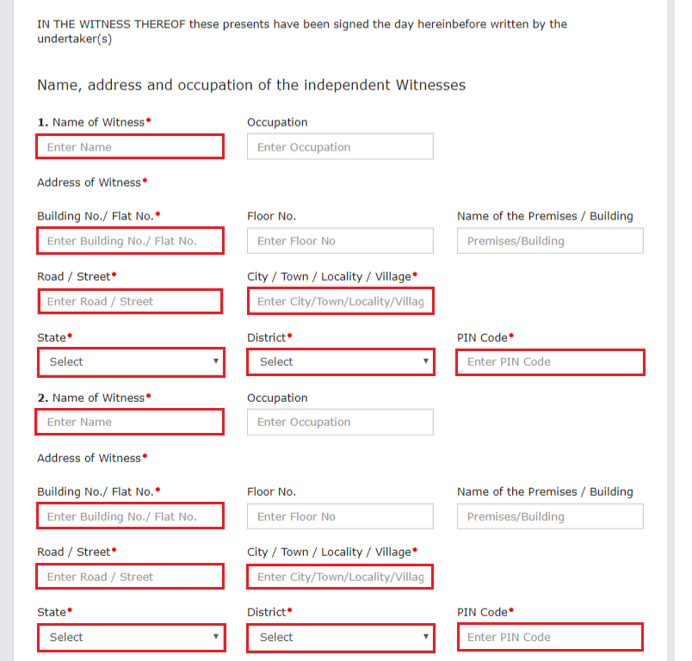

Note that the Witnesses declared in the Letter of Undertaking (LUT) are the ones declared on the running Bond/ Bank guarantee.

**Step 5:** Enter the Place of filing > Click on ‘SAVE’ > click on ‘PREVIEW’ to verify the correctness of the form before submission

Note that currently, the revision of a signed/submitted form is not possible.

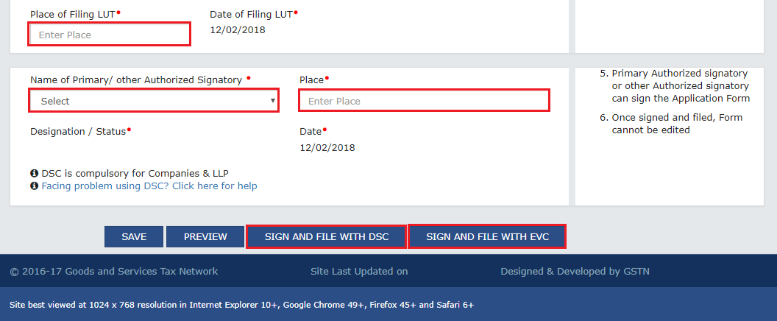

**Step 6:** Sign and file the form using either of the below options:

Who Should sign?- The Primary authorised signatory/ any other authorised signatory can sign the Letter of Undertaking.

Authorised signatory can be the working partner, the Managing Director or the Company Secretary or the proprietor or by a person duly authorised by such working partner or Board of Directors of such company or proprietor to execute the form.

* **Submit with DSC:** Sign the application using the registered Digital Signature Certificate of the selected authorized signatory.

To use this option, Click on ‘SIGN AND FILE WITH DSC’ > Warning message box appears > Click

‘PROCEED’> System generates a unique ARN (Application reference number)**

**OR**

* **Submit with EVC:** To use this option, Click on ‘SIGN AND FILE WITH EVC’ > The system will trigger an OTP to the registered mobile phone number and e-mail address of the authorized signatory. Enter that OTP in the pop-up to sign the application > Warning message box for submission appears > Click ‘PROCEED’> System generates a unique ARN (Application reference number)**

Note : Companies and LLPs can file only using DSC

** A confirmation message appears. GST Portal sends this ARN at registered email and mobile of the Taxpayer by e-mail and SMS.

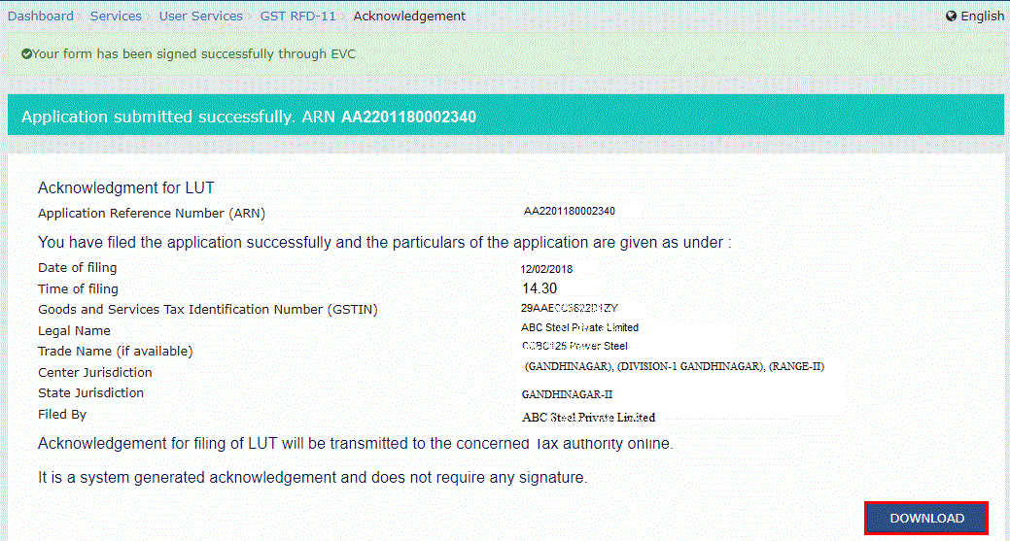

You can click on the **DOWNLOAD** button to download the acknowledgement.

You may also check out the Letter of Undertakings previously furnished on the GST portal. On the home page, Go to ‘SERVICES’ > ‘ User Services’ > ‘View my Submitted LUTs’ > Select period > Check out the list of LUTs furnished during the selected period > Click ‘VIEW’ against the particular Letter of Undertaking to view the detail.

For further reading on Export procedures, check out: